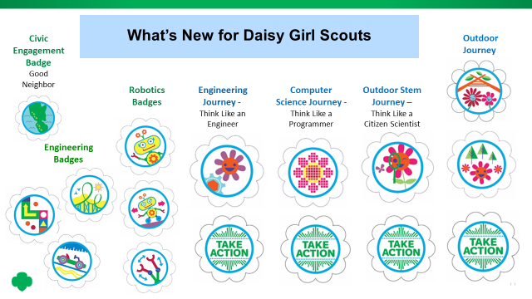

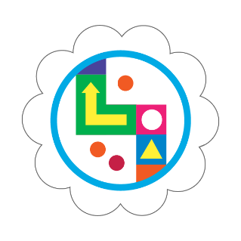
Board Game Design Challenge
Engineers are people who like to know how things work. They design and build things people use every day, like computers, phones, roads, bridges and cars. They use their imaginations to solve problems and create new products. Create board games and engineer your own game spinner using GoldieBlox.
- Come up with an idea for your board game
- Design a spinner for your game
- Test your game and make it better
When I’ve earned this badge, I will have created my own board game and learned what inventors and engineers do.
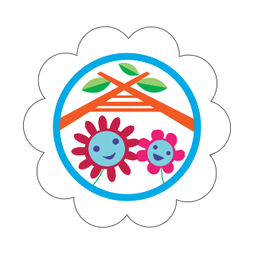
Buddy Camper
Camping is an adventure! You play in nature, eat outside, and sleep under the stars with your family or buddies - your buddies could be the girls in your troop, or other friends. Are you ready to go camping?
- Help plan a camping trip
- Help pack for your trip
- Go camping
When I’ve earned this badge, I’ll know how to go camping—at a campsite or in a back yard—with my family or friends.
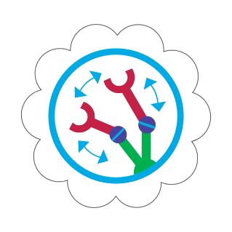
Design a Robot
Now that you know what robots can do and how they do it, it’s time to design your own robot! Work like engineers to plan and build a prototype of your robot that solves an everyday problem. Don’t forget to make a program for your robot, as it will need it for your prototype to “run." After, test and share your robot prototype with your fellow Daisies for ideas on how to make it even better.
- Plan your robot
- Create a prototype
- Get feedback on your robot
When I’ve earned this badge, I will know how to plan, build, and share feedback like an engineer by creating a prototype of a robot that solves an everyday problem.
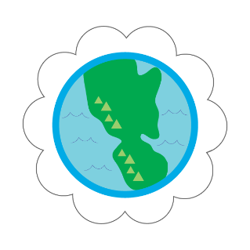
Good Neighbor
Groups of people are called communities. You’re part of lots of communities! Your Daisy troop is one, and so is your class at school. You can help your communities by being a good neighbor. Find out how in this badge.
- Explore your school
- Discover your city or town
- See what makes your state special
When I’ve earned this badge, I’ll know more about the communities I belong to—and how the people in my communities work together to be good neighbors to each other.
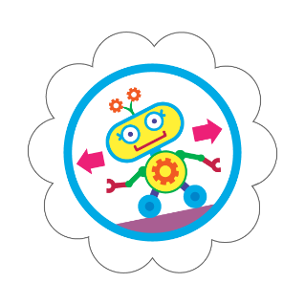
How Robots Move
Robots are simple machines made of many different parts that are programmed to run automatically. Programmers are the engineers that create step-by-step instructions, or algorithms, that tell robots how to move, understand, and act. Think you might be a good robot? See if you can follow your programmer’s algorithm. After, become a programmer, and create algorithms for robots and friends.
- Learn about the parts of a robot
- Find out how robots move
- Make a robot move
When I’ve earned this badge, I will know about the parts of a robot and how to create a program that could be run by a robot.
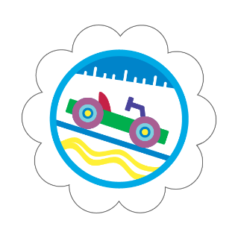
Model Car Design Challenge
When engineers design something new, they need to think about forces like gravity and friction. Friction is a force that slows and stops moving objects. Without friction, any object that was pushed or pulled would keep moving forever. Build a model car out of GoldieBlox and test the friction of your car on different surfaces to prepare for a Troop Car Chase!
- Design and build model cars
- Use model cars to test the friction of different surfaces
- Race your cars!
When I’ve earned this badge, I will have learned about friction by building and testing model cars. I will know how to design and test new things that I invent.
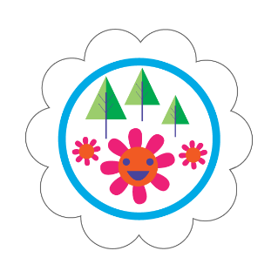
Outdoor Art Maker
From a blue sky to a bird’s song, nature can give you lots of ideas for art! Get ready to explore the outdoors and use what you see and hear to make different kinds of art projects.
- See the colors of nature
- Hear the sounds of nature
- Share your outdoor art
When I’ve earned this badge, I’ll know how to look at nature like an artist and make my own outdoor art.
Roller Coaster Design Challenge
Engineers use their imaginations to solve problems. They invent and build things that can be used in the real world. Engineer your own roller coaster using GoldieBlox to see how its design affects its speed.
- Make a simple roller coaster car
- Build a model of a roller coaster
- Test your roller coaster
When I’ve earned this badge, I will have learned about engineering and motion by building and testing a roller coaster.
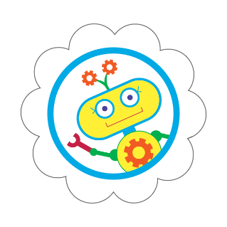
What Robots Do
A robot is a machine that is programmed to act automatically. Robots do things we, as humans, can’t or don’t like to do. Robots can be super small to go into small spaces or be built to go places that are too hot or cold for us. They can even go to far away planets and send information back to scientists! Learn about the many things robots do, and work in teams, like engineers, to design a robot that solves an everyday problem.
- Learn about robots
- Find out what robots can do
- Team up to design your own robots
When I’ve earned this badge, I will know about the many things robots can do and the steps engineers take to build a robot in teams.
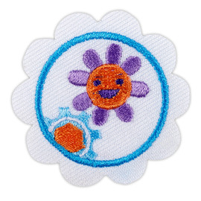
Think Like an Engineer Journey. Girls discover how to think like an engineer by participating in hands-on design challenges and completing a Take Action project.

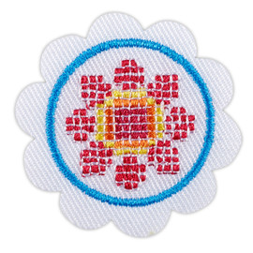

Think Like a Programmer. Girls learn how programmers solve problems as they (girls) participate in interactive computational-thinking activities and complete a Take Action project.

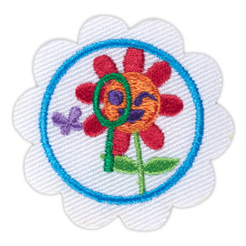

Think Like a Citizen Scientist. Girls practice the scientific method by undertaking a citizen science project. They make observations, collect data, and work with scientists who provide feedback on research and findings. Girls also complete a Take Action project.

